Biology 313
Discussion for the week of 11-6, 2017
17 points
1. (7pts) Suppose you were just watching the latest film, “The Dark Current” and you walk from the dark theater out into the bright sunny Binghamton afternoon. At first, the light is “blinding” and you can’t see! But after a time your photoreceptors adapt to the new light levels.
a. When light reaches your photoreceptors, what happens to:
Transducin?
Transducin (G-Protein) is activated
Phosphodiesterase?
Starts to break down cGMP
cGMP?
cGMP and turns it into 5'GMP, causing ion channels to close
b. What happens to the Ca++ levels in the photoreceptor when you step into the bright light?
Na+ channels(that are Ca++ permiable) close up, Ca++ conc in photoreceptors is reduced.
Why?
Stated in part b
c. How does this change in Ca++ alter the open/closed state of the Na+ channels?
When you enter bright room, reduced Ca++ from Na+ channel closing increases cGMP levels, so Na+ channels start to open more.
d. And why are you able to see again?
Less Ca++ in bright area means that cGMP levels can be increased, more can open Na+ channels. Leads to some Na+ channels are open, some closed, and you see again.

2. (5pts) Shown here are stimuli applied to different parts of the receptive field of an off-center, on-surround bipolar cell. The stimulus is the shaded area, the receptive field is shown as the two concentric circles. For each example,
a. draw the expected response of the bipolar cell.
b. beneath it, draw the response of the ganglion cell that is postsynaptic to that bipolar cell

Bipolar:
OFF: Bipolar cell - nt (glutamate) is an excitatory nt
ON: For others, glutamate is inhibitory. inhibition is shut off and bipolar cell depolarizes

Ganglion cell:
recording from ganglion cell
ON response
---------- (light on)
-|-|----||||||||||-----|------|------ (action potentials)
OFF response
---------- (light on)
-|-|--|----|-------|--|---|---|--|---- (dec in action potentials)

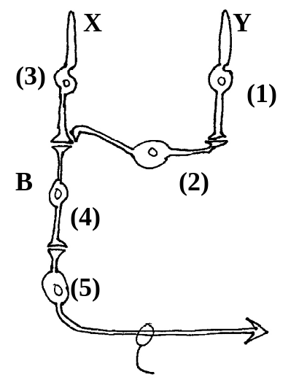
3. (10 pts) The following diagram represents the interactions of photoreceptors X and Y with an on-center bipolar cell, B. The numbers
represent where recordings are made

a) When light falls on Photoreceptor Y, Draw the expected changes in Vm at recording sites 1-5. Be sure to label your axes properly
Vm
time

(1) (2)
Vm
time

(5) light on
Vm
time
(3) (4)
Vm
time
Vm
time
?

4. Your TA will show you a number of optical demonstrations that illustrate various aspects of visual processing (To do in discussion).

a) Plot out your blind spot!

b) Effect of Background contrast on the perception of brightness: This demonstration illustrates the function of retinal ganglion cells and how they are especially tuned to detect contrasts. The center bar reflects the same amount of light all along its length. The differences in brightness that you see are due to the different degree of contrasts between the background and this bar.

c) Random dot stereograms: These illustrate how the small disparity between images entering your two eyes is used by the brain to perceive depth. Two identical random dot patterns are first created. Then for one of these patterns, the dots are shifted laterally by one row. If each eye stares at a different pattern (you have to let your eyes diverge), after a few seconds (give it some time- your brain is trying to deal with this unusual situation), a single image will emerge in 3-D.

